Universidad Europea de Madrid

Fluid Mechanics II

Homework 1

Due on September 19, 2016

**Problem 1**

A Couette pump consists of a rotating inner cylinder and a baffled entrance and exit, as shown in below figure. Assuming zero circumferential pressure gradient and (a-b)<<<a, derive formulas for the volume flow and pumping power per unit depth. Illustrate for SAE 30 oil at 20°C, with a=10cm, b=9cm and ω =600rpm

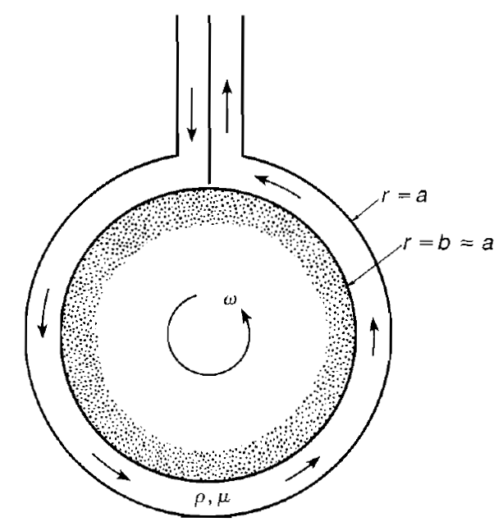

**Problem 2**

In figure two infinite plates are 2h apart, and the upper plates moves at speed U relative to lower. The pressure is assumed constant. The upper plate is insulated and the lower plate the heat transfer is due to convention. These boundary conditions are independent of x and z (infinite plates), hence it follows that u=u(y) and T=T(y). Find the velocity and temperature distribution of the fluid.

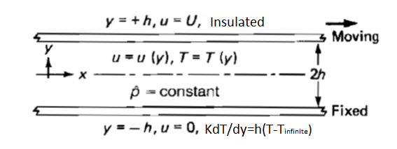

Governing equations:



Where φ is :



**Problem 3**

Air at 20°C and 1atm is at rest between two fixed parallel plates 2 cm apart. At time t=0, the lower plate suddenly begins to move tangentially at 30cm/s. Compute the air velocity in the center between plates after 2s. When will the center velocity reach 14cm/s?